Timeline(Errors):

- After completing the code, we did all of our debugging in one day because of time and convenience purposes.

**(1) 5/9:**

Bug: The CPU’s hand was also printed

Before- 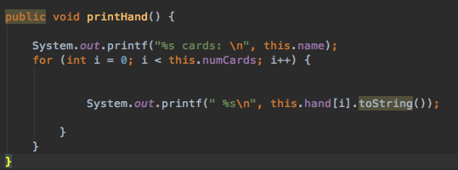

After-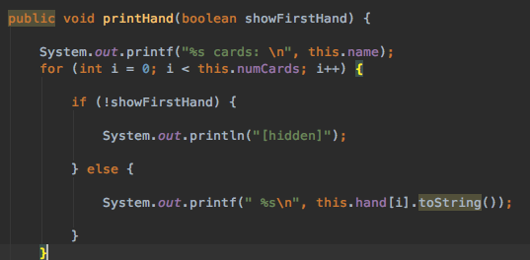

**(2) 5/9:**

Bug: 11,12 and 13 were added for jacks, queens and kings respectively.

Before - 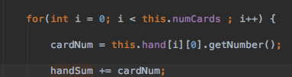

After - 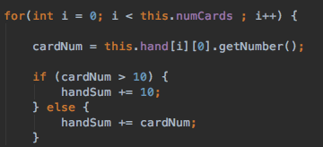

**(3) 5/9:**

Bug: Both the dealer and the player went over 21 as their final values.

Fix: Changed the if statement to see if user got over 21 as well( added && user.score > 21)

Before- 

After -



**(4) 5/9:**

Bug: The cash amount became negative and the game continued.

Before- 

Fix: Changed the while loop to take account for less than 0 instead of just not 0.

After - 

**(5) 5/9:**

Bug: Even after the fix above the game continued and printed out the final cards and asked if the player wanted to play again.

Before - 

After - 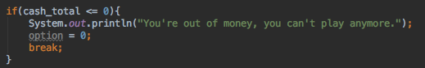

**(6) 5/9:**

Bug: The bet amount entered more than total cash or is negative.

Fix: We added another while loop before the gameplay code to check if the bet amount is over zero and less than



**(7) 5/9:**

Bug: User enters a number when asked for a char and game quits

Before - 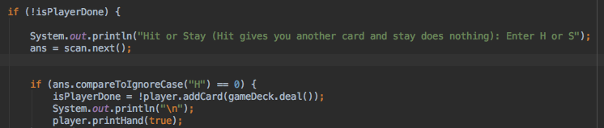

After - 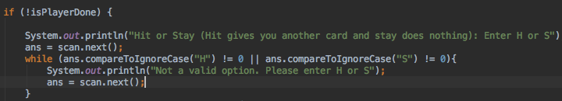

**(8) 5/9:**

Bug: Game kept telling user that H wasn’t a valid option, even though i is.

Before - 

After - 

**(9) 5/10:**

Bug: Game continued even when cpu no longer needs more cards

Before- 

After - 